`
How to Install Realogy Mobile Printers - Denver

1. How to Install Realogy Mobile Printers
3
The Realogy Mobile Print lets you print from any smartphone, tablet or laptop to an enabled printer at your location

Double Click on the attached “Realogy Profile for Denver Printers file included in the email

>click open > click continue (to install) > (are you sure) click install

Go to System Preferences
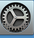

Go to Printers and Scanners
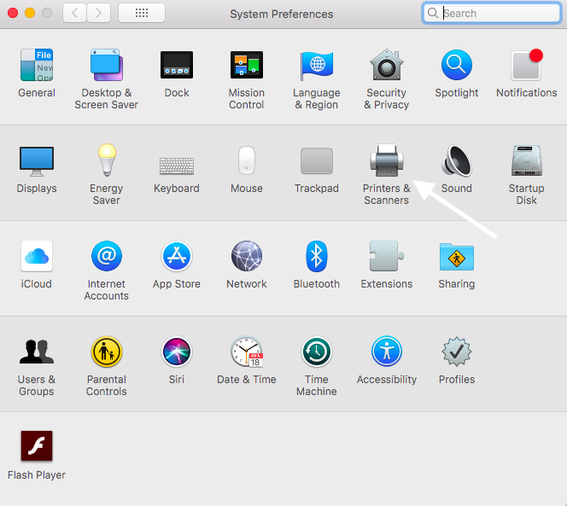
>open printers & scanners

Click the plus button (add) on the bottom left corner
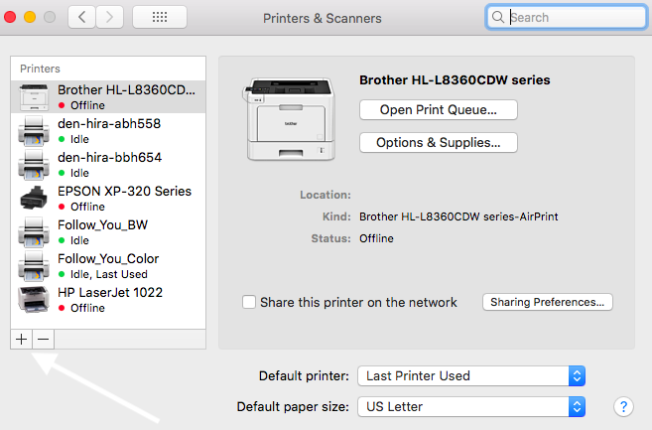

Select the printer you would like to add
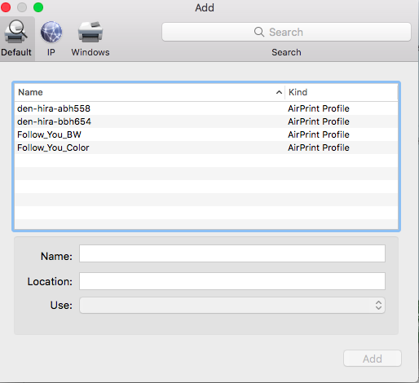
>Click Add

Printer will be installed.
(Cont.)

The first time you print you will need to authenticate to Realogy
Open the Printer that appears in the bottom tool bar>click the refresh button
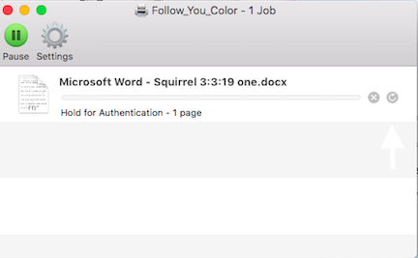

Authentication is only required 1 time, unless you change your password
or Realogy’s Okta requires it.
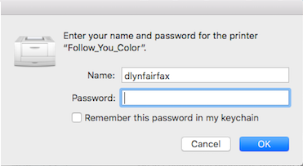

You are ready to print.

