For Apple Computers

PrinterCloud only works in Google Chrome Browser

- Access the PrinterCloud portal by logging into https://mycbdesk.com/
and selecting the PrinterCloud tile.

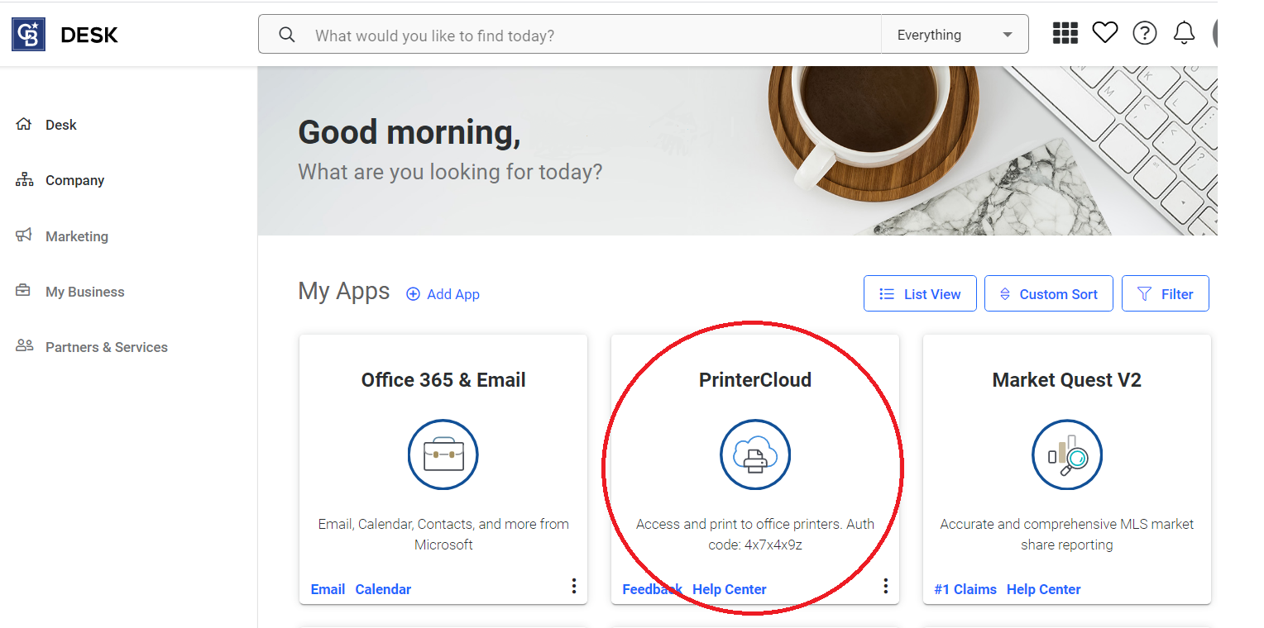

You can also access the PrinterCloud portal by entering the following URL in your Chrome Browser: https://realogy.printercloud.com.

- You will be prompted to install the Chrome Extension. Click Install.
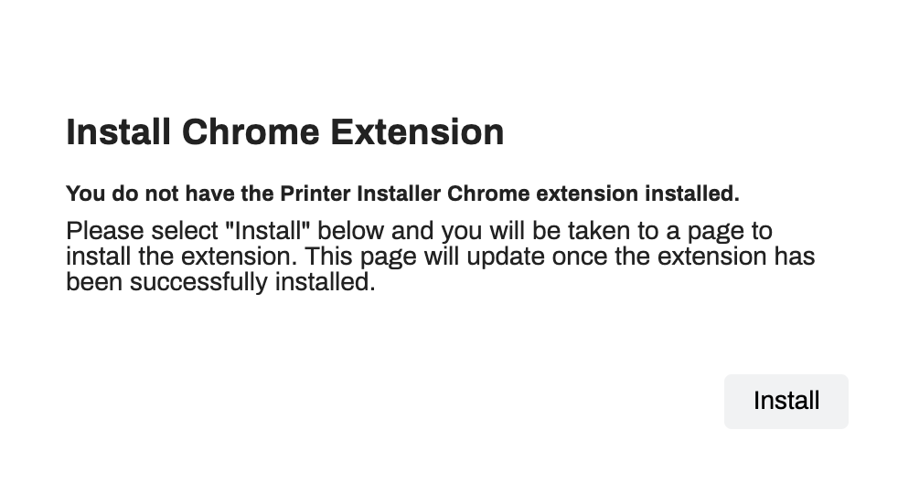

- Click INSTALL EXTENSION.

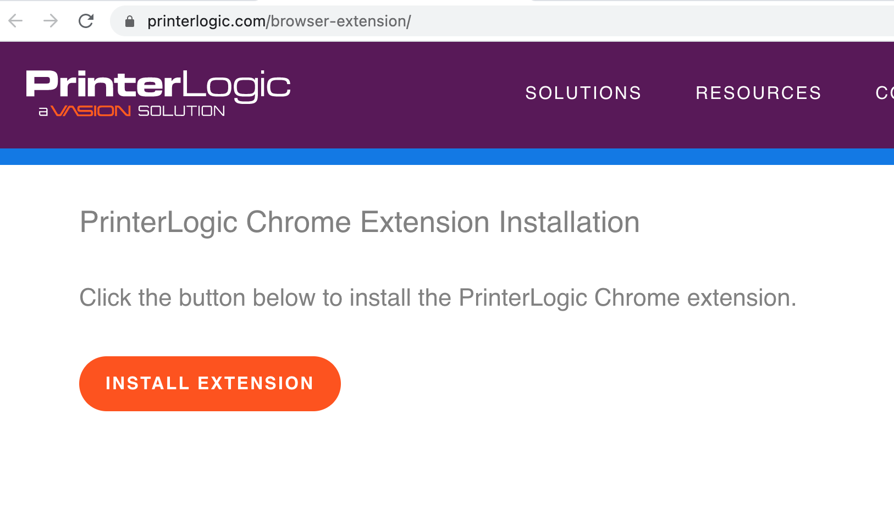
- Click Add to Chrome.

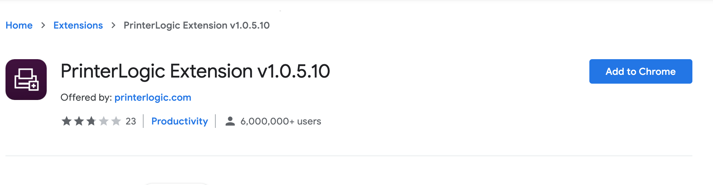

- Click Add extension. You have successfully installed the Chrome extension.

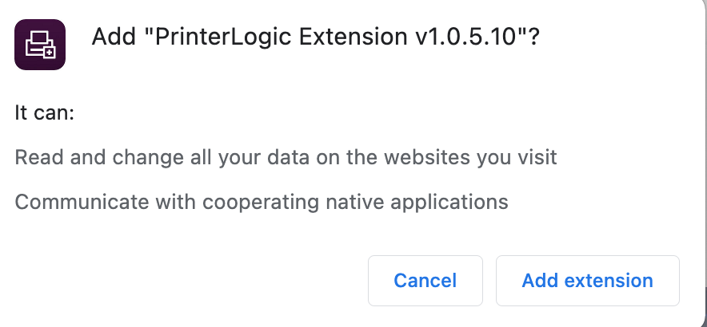

- To install the Printer Installer Client, go to: https://realogy.printercloud.com and click Install.

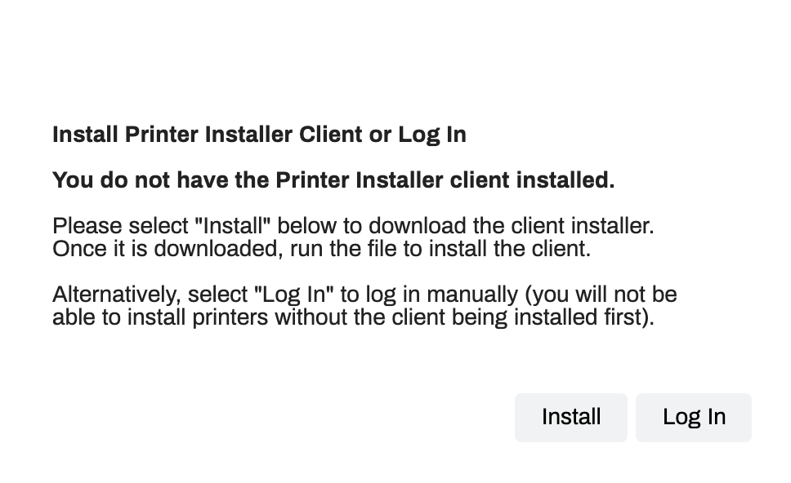

- The program will automatically download. Click Open to install the Printer Installer Client.

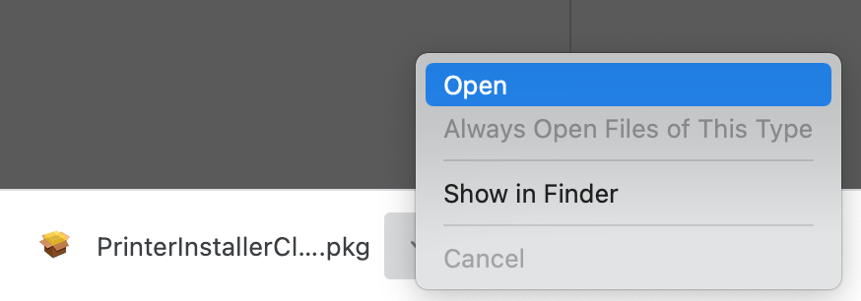

- Close all the Windows you have open. Click on the center of the screen and on the top select Go, select Downloads.

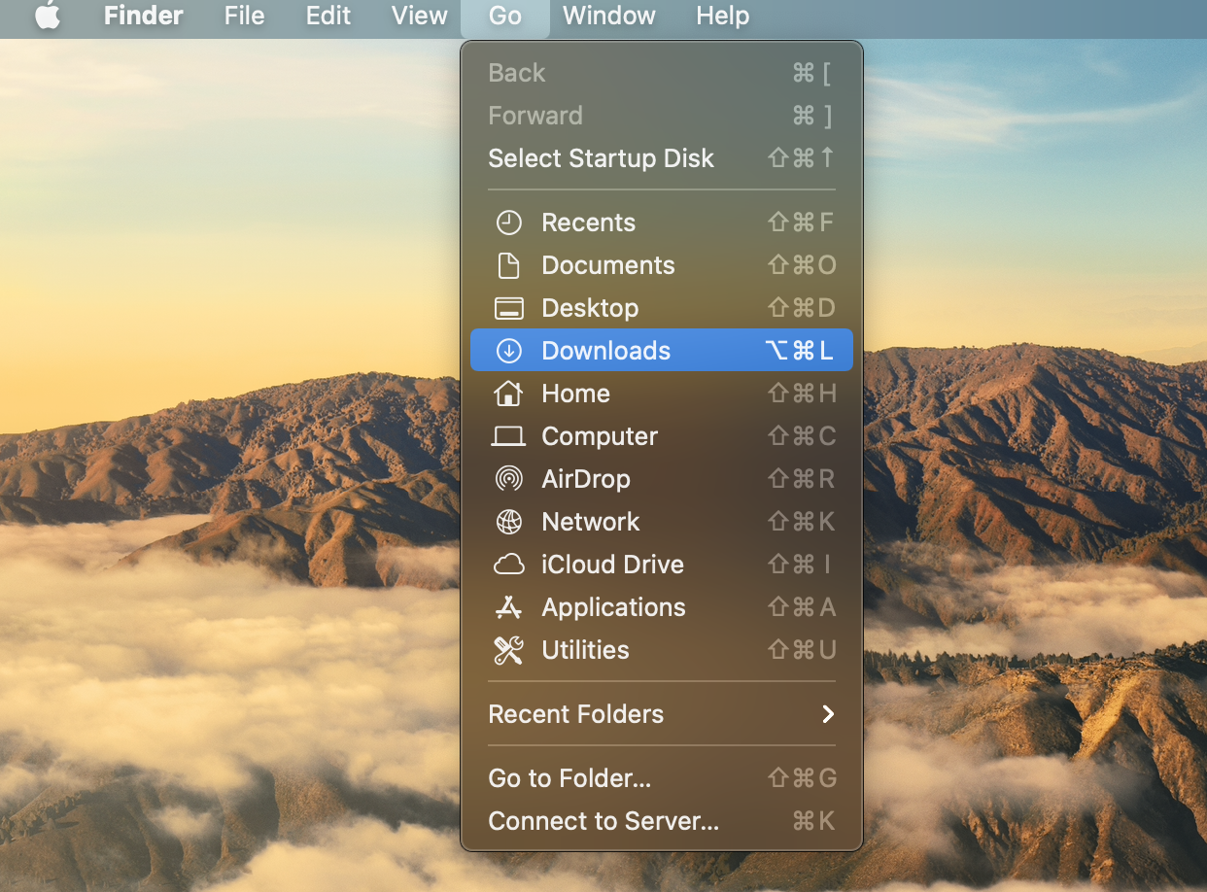

- Locate the downloaded PrinterInstaller ClientSetup.pkg file.
Press and Hold the Control Key on your keyboard and click on PrinterInstallerClientSetup.pkg. Then click Open.

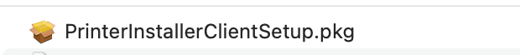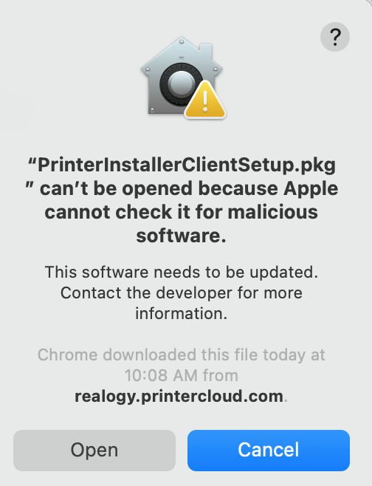

- Follow the Installer Prompts to complete the Installation.

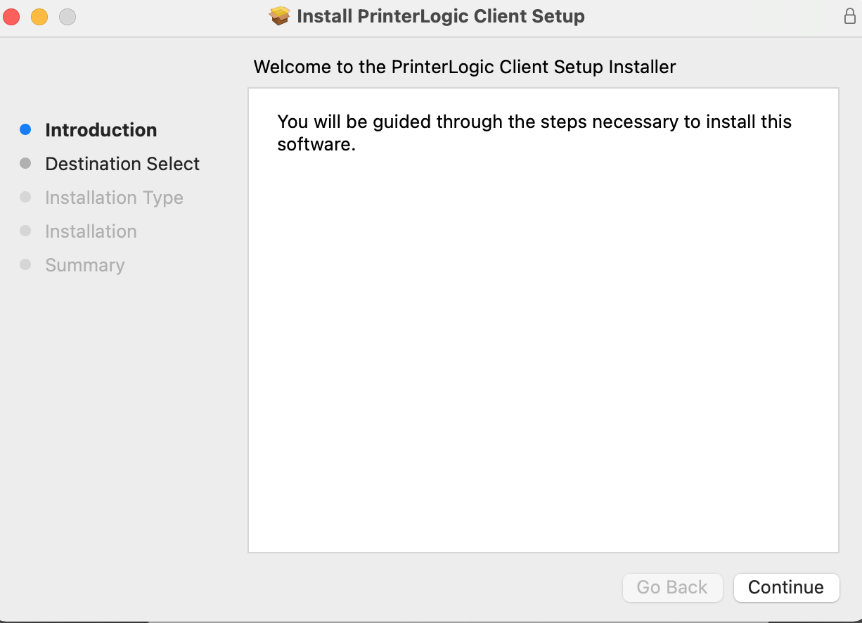

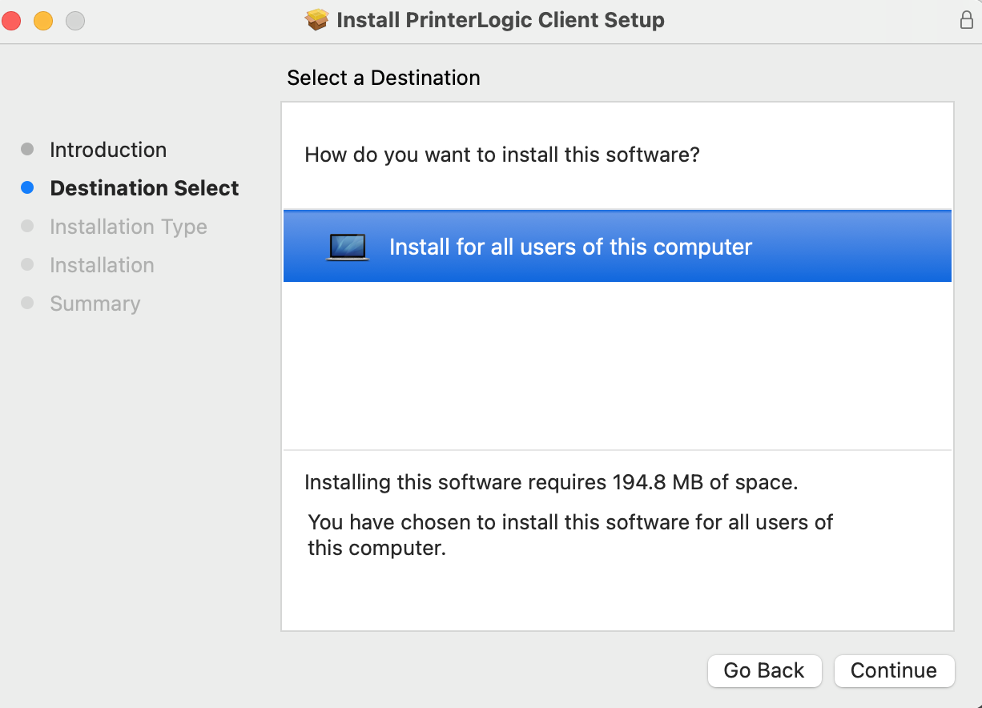

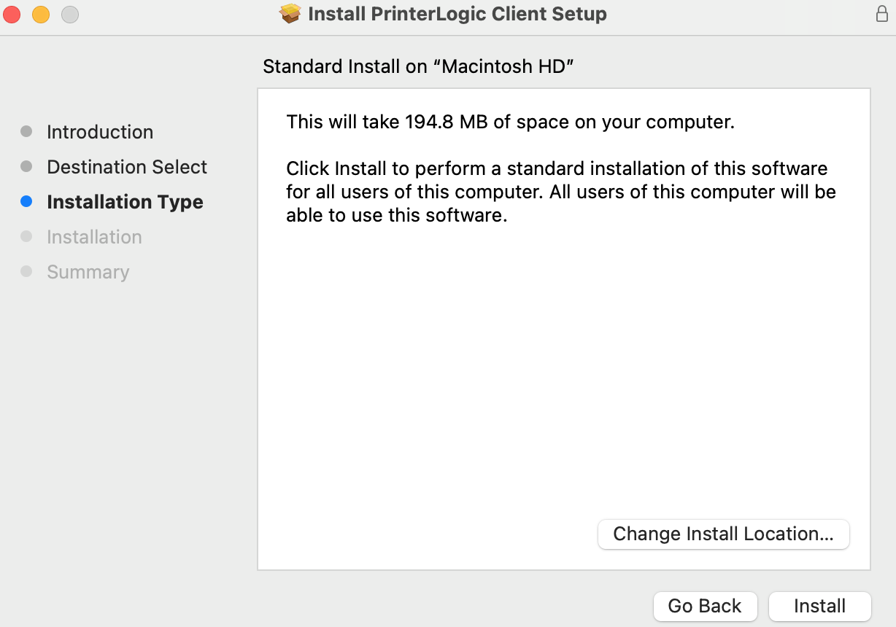

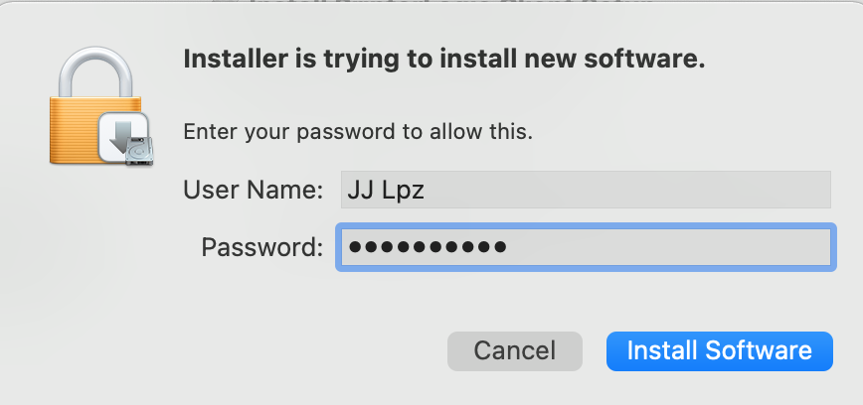

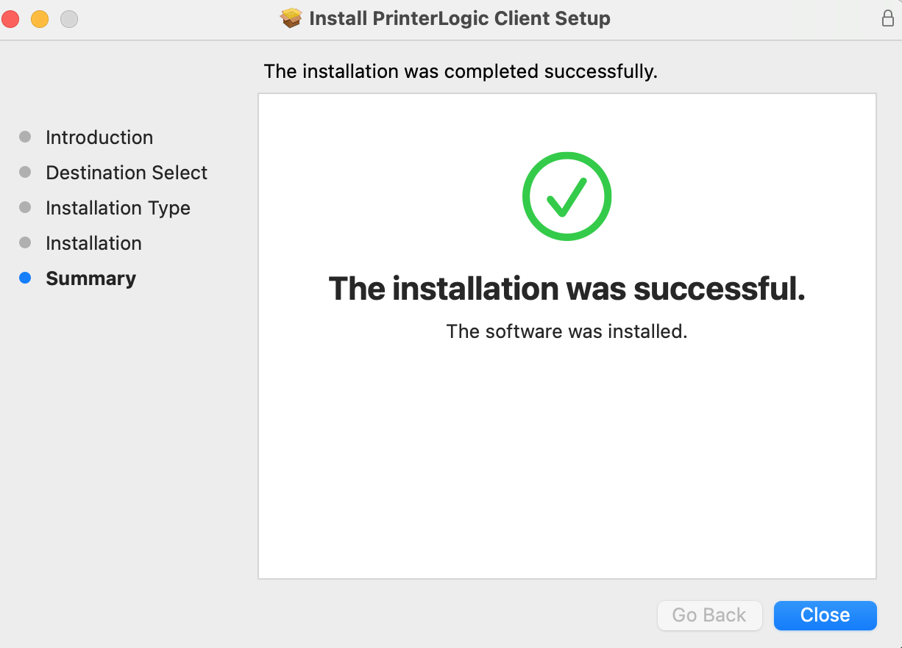

You are now ready to add a printer. Please proceed to the “How to Add a Printer using PrinterCloud” instructions.

How to Add a Printer using PrinterCloud

PrinterCloud only works in Google Chrome Browser

- Log into MyCBDesk and select the PrinterCloud tile

- Enter an Authorization Code. The Code is 4x7x4x9z and click OK.
Note you will only have to enter this Code the first time you use this program.

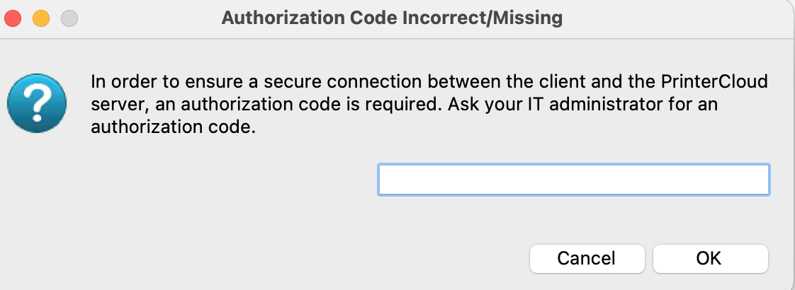

- You will be directed to your office folder where a map of the office and printer locations will be displayed.

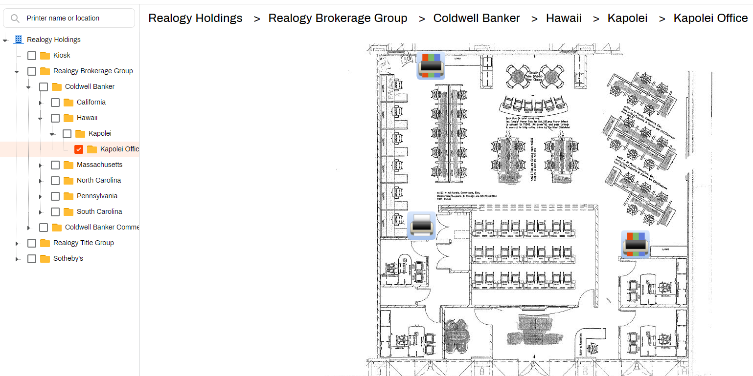

What if my office folder does not have a map?
If there is no map displayed in the office folder, then you will only see a screen indicating the printers available for install (see image below).

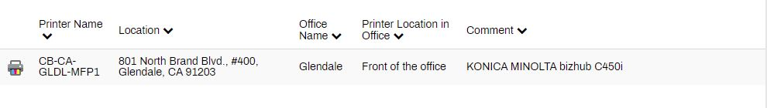

- Hover the mouse over the printer you would like to install, click Install Printer. Click Yes, to start the installation.

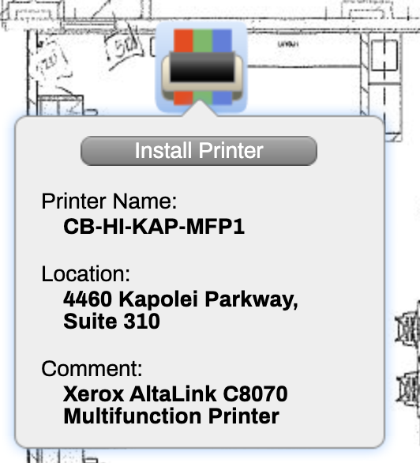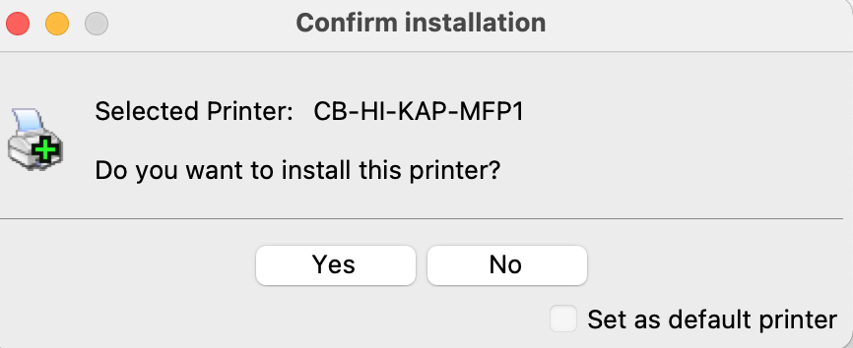

- Once the Printer is installed you will get the following message.

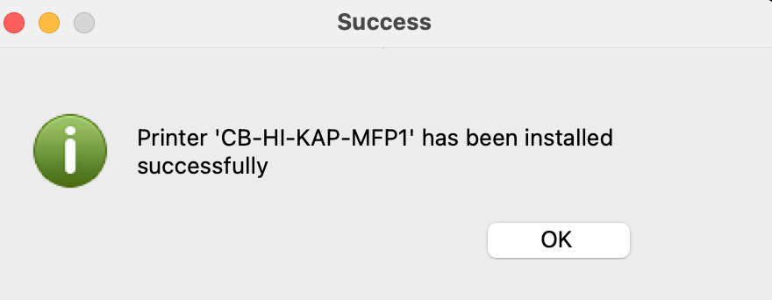

- Please note, the printer will be named using the following criteria in your printer’s folder: CB-State-City-MFP1 (Multi-Function-Printer).

If you need Help, please contact the Help Desk at 877-678-4357.

**Note
ChromeBook and Windows Home S Version are not supported.

iOS (iPhone, iPad) and Android devices (mobile printing) are not supported by PrinterCloud at this time.

